

**Du Lich Do Day Software Architecture**

**Project Code: #01**

**Document Code: Architecture Design– v1.0**

**< >**

Internal use

**RECORD OF CHANGE**

*A - Added M - Modified D - Deleted

|  |  |  |  |  |
| --- | --- | --- | --- | --- |
| **Effective Date** | **Changed Items** | **A* M, D** | **Change Description** | **New Version** |
| 19/03/2018 | First vesion | A | N/A | 1.0 |
|  |  |  |  |  |
|  |  |  |  |  |
|  |  |  |  |  |
|  |  |  |  |  |
|  |  |  |  |  |
|  |  |  |  |  |
|  |  |  |  |  |
|  |  |  |  |  |
|  |  |  |  |  |
|  |  |  |  |  |
|  |  |  |  |  |
|  |  |  |  |  |
|  |  |  |  |  |
|  |  |  |  |  |
|  |  |  |  |  |

**SIGNATURE PAGE**

|  |  |  |
| --- | --- | --- |
| **ORIGINATOR:** | Hoang Van Nghiep  <Position> | 19/03/2018 |
| **REVIEWERS:** | <Name>  <Position> | <Date> |
|  | <Name, if it’s needed>  <Position> | <Date> |
| **APPROVAL:** | <Name>  <Position> | <Date> |

**TABLE OF CONTENTS**

1. INTRODUCTION 5
   1. Purpose 5
   2. Scope 5
   3. Definitions, Acronyms and Abbreviations 5
   4. References 5
   5. Overview 6
2. ARCHITECTURAL REPRESENTATION 6
3. ARCHITECTURAL GOALS AND CONSTRAINTS 6
4. USE-CASE VIEW 6
   1. Use-Case Realizations 6
5. LOGICAL VIEW 7
   1. Overview 7
   2. Architecturally Significant Design Packages 7
6. PROCESS VIEW 7
7. DEPLOYMENT VIEW 7
8. IMPLEMENTATION VIEW 8
   1. Overview 8
   2. Layers 8
9. DATA VIEW (OPTIONAL) 8
10. SIZE AND PERFORMANCE 8
11. QUALITY 8
12. OTHER CONSIDERATIONS 9

# INTRODUCTION

This document provides information about how the application works.

## Purpose

This document provides a comprehensive architectural overview of the system, using a number of different architectural views to depict different aspects of the system. It is intended to capture and convey the significant architectural decisions that have been made on the system.

# ARCHITECTURAL WORK FLOW

#1. Màn hình đăng nhập #2. Màn hình đăng ký

#3 Màn hình chính

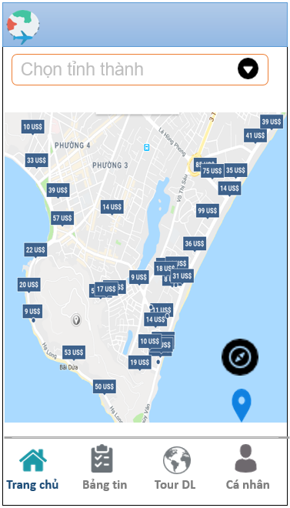#3 Màn hình chính Địa điểm quanh đây

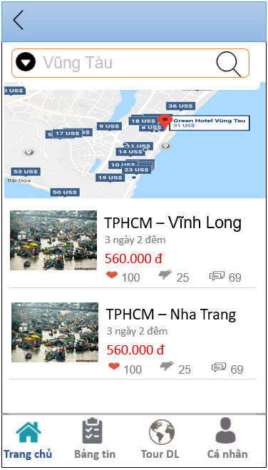

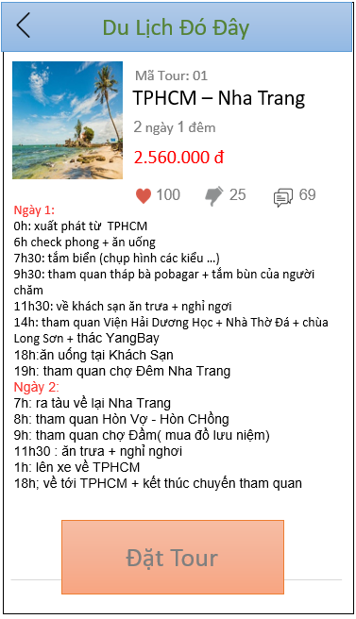

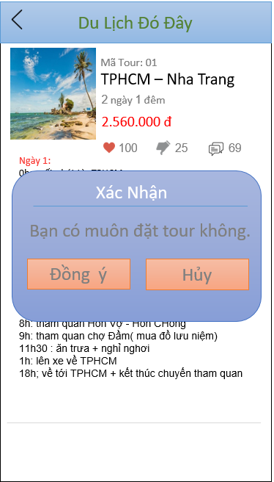 #4. Chi tiết tour Xác nhận đặt tour

#5. Tour Du Lich

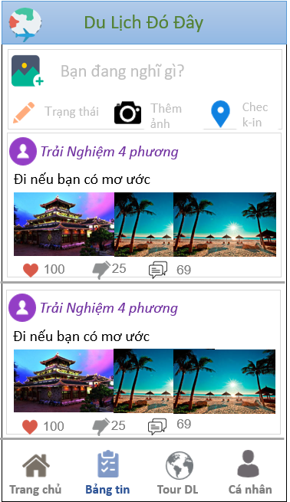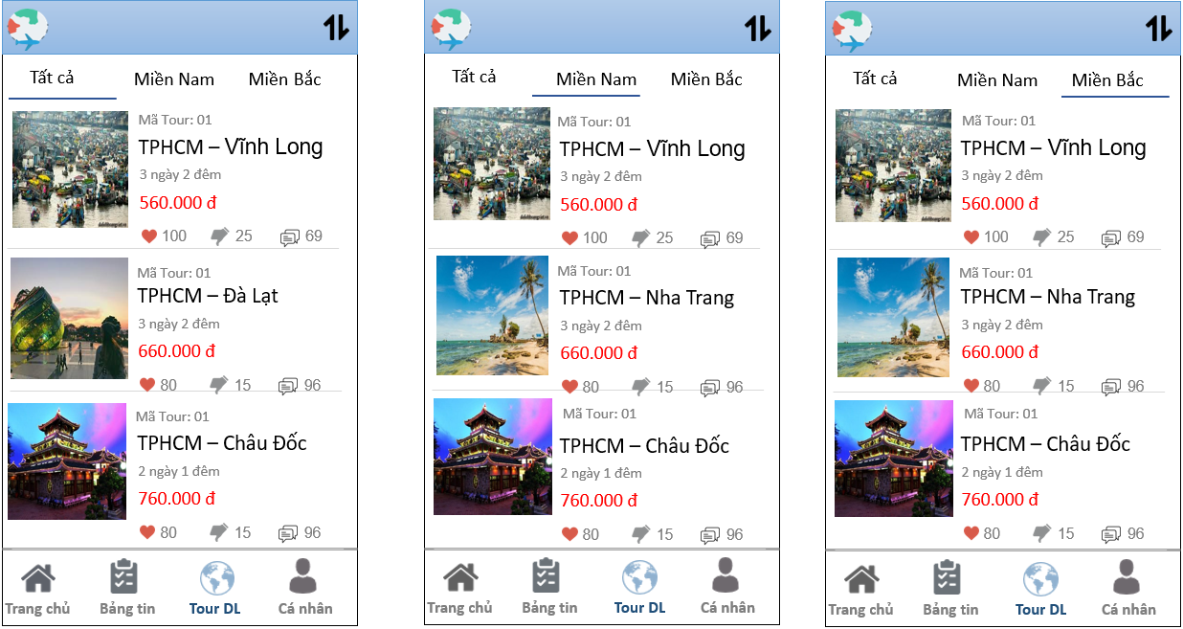 #5 Tour Du Lich

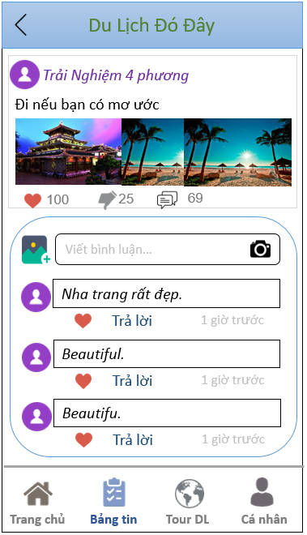 #6. Bảng tin Bình luận bảng tin

